Financial Performance Analysis: Evaluating the Role of Efficiency and Leverage Across Firms
Chelsea Anestal
April 26, 2026
Introduction
This project analyzes firm-level financial data to understand what drives financial performance across companies over time. The dataset consists of 100 companies observed over a 10-year period (2016-2025), including key financial metrics such as revenue, profitability, leverage, and efficiency ratios.
The primary objective of this analysis is to evaluate whether commonly cited financial drivers, specifically leverage and efficiency, have a meaningful impact on firm performance. Financial performance is primarily measured using net profit margin, with supporting metrics such as revenue and EBIT margin.
This analysis ultimately finds that financial performance is less driven by leverage and efficiency in isolation, and more strongly associated with firm scale, revenue momentum, and consistent cost structure discipline.
Data Overview
The dataset contains approximately 1,000 observations over 200 variables, including financial statement data, ratios, and engineered time-series features. For the purposes of this analysis, a subset of variables was selected to maintain clarity and focus.
Key variables used include:
- Performance metrics: net_margin, ebit_margin, revenue_growth. These measure how well a company is doing financially. Net margin is the percentage of revenue a company keeps as profit after paying all of its expenses, including taxes and interest. It is the most comprehensive measure of profitability as it does not exclude anything. EBIT margin standards for Earnings Before Interest and Taxes margin. It measures the profitability before accounting for how the company is financed (interest on debt) and its tax obligations. Revenue growth measures how much a company’s total sales increased (or decreased) compared to the previous year, expressed in percentage.
- Leverage: debt_ratio. This measures how much a company relies on borrowed money to fund its operations. Debt ratio is the proportion of a company’s total assets that are financed by debt rather than by the company’s own equity. A higher ratio means the company carries more financial risk, since debt must be repaid regardless of business performance.
- Efficiency: asset_turnover, revenue_per_employee. These measure how effectively a company uses its resources to generate revenue. Asset turnover measures how much revenue a company generates for every dollar of assets it owns. A higher number indicates a company is using its assets more productively. Revenue per employee measures the average amount of revenue generated by each employee. It is a practical indicator of workforce productivity. A higher value suggests the company is getting more output from its people.
- Other supporting metrics: revenue, free cash flow (FCF), earnings per share (EPS). These provide additional context on financial health and shareholder value. Revenue is the total amount of money accompany earns from its sales of goods or services before any expenses are deducted. Free cash flow (FCF) is the cash a company has left over after paying for its operating expenses and capital investments, such as equipment or infrastructure. Earnings per share (EPS) divides a company’s total profit by number of shares outstanding, giving a per-share measure of profitability.
This selection allows for a targeted analysis of the relationship between firm performance and its potential drivers.
Data Preparation
The dataset was largely clean and structured prior to analysis. Preparation steps included:
- Loading CSV data in the appropriate tools including Excel, R Studio, and Tableau.
- Verifying data completeness and handling any missing values. In some instances, missing values were expected, for instance, when calculating year-over-year revenue, the first year would be expected to have no data since there was not data to compare against. In cases where values were structurally missing (e.g., first-year revenue growth), values were set to 0 to preserve continuity in analysis, as no prior period existed for comparison.
- Selecting a focused subset of relevant variables. This subset included the performance metrics, leverage, efficiency, and other supporting metrics.
- Aggregating or filtering data where appropriate for visualization.
- Converting year into a categorical variable for time-based analysis.
Feature selection was performed to reduce dimensionality and focus analysis on interpretable financial drivers. No major transformations were required due to the high quality of the dataset.
Exploratory analysis
4.1 Numerical and Tabular Summaries (Excel)
Descriptive statistics were generated on key variables such as the revenue, revenue growth, EBIT margin, net margin, asset turnover, and debt ratio. These summaries (Figure 1) revealed significant variability across firms, particularly in financial output measures such as revenue and free cash flow.
Revenue was highly skewed and dispersed. The mean (~$20.1B) sits well above the median (~17.6B), and the skewness of 1.22 with kurtosis of 1.94 confirms a right-skewed, leptokurtic distribution. A handful of very large firms are increasing the average overall. The standard deviation of ~$14B relative to the mean signals enormous size variation across the sample.
The revenue growth averages ~11.4% with a median close by (~11.2%), suggesting a fairly symmetric distribution (skewness of 0.34, kurtosis slightly negative). The range spans from -12% to +38%, so there’s meaningful variation in performance, but most companies cluster around moderate growth.
The profitability margins including EBIT (~18.8%) and Net (~14.1%) are both quite stable, low standard deviations, near zero skewness, and slightly negative kurtosis (platykurtic), meaning firms are spread fairly evenly around the mean with few extreme outliners. These distributions are consistent with mature, operationally stable firms.
The asset turnover averages 0.48, meaning companies generate about $0.48 in revenue per dollar of assets. The slight positive skew suggests some higher-efficiency outliers, but the distribution is relatively flat (kurtosis near -1).
In terms of leverage, the debt ratio averages 0.40, indicating moderate leverage on average. It is nearly perfectly symmetric (skewness ~0.02) and platykurtic, the companies are spread evenly across the leverage spectrum with no extreme outliers.

Figure 1: Descriptive statistics table (mean, median std dev, min, max) for key financial ratios and revenue metrics (Excel)
 | Revenue | Revenue_Growth | EBIT_Margin | Net_Margin | Asset_Turnover | Debt_Ratio
Mean | $ 20,078,937,655.09 | 0.113519 | 0.18761 | 0.14082 | 0.48231 | 0.40028
Standard Error | $ 441,994,294.78 | 0.003173 | 0.00170 | 0.00131 | 0.00276 | 0.00276
Median | $ 17,575,336,846.93 | 0.111791 | 0.18701 | 0.14116 | 0.46653 | 0.40140
Mode | #N/A | 0.000000 | #N/A | #N/A | #N/A | #N/A
Standard Deviation | $ 13,977,086,843.03 | 0.100341 | 0.05371 | 0.04156 | 0.08739 | 0.08714
Sample Variance | $ 195,358,956,617,706,000,000.00 | 0.010068 | 0.00289 | 0.00173 | 0.00764 | 0.00759
Kurtosis | 1.94 | -0.541573 | -0.57685 | -0.51859 | -0.99592 | -1.22265
Skewness | 1.22 | 0.339073 | -0.00823 | 0.07283 | 0.44124 | 0.01849
Range | $ 89,273,986,348.29 | 0.502575 | 0.25961 | 0.21368 | 0.30909 | 0.29936
Minimum | $ 738,940,414.08 | -0.119703 | 0.05446 | 0.04258 | 0.35744 | 0.25008
Maximum | $ 90,012,926,762.38 | 0.382872 | 0.31408 | 0.25627 | 0.66653 | 0.54944
Sum | $ 20,078,937,655,091.60 | 113.518668 | 187.61125 | 140.82211 | 482.31047 | 400.27922
Count | 1,000.00 | 1000.000000 | 1000.00000 | 1000.00000 | 1000.00000 | 1000.00000
Confidence Level(95.0%) | $ 867,343,730.23 | 0.006227 | 0.00333 | 0.00258 | 0.00542 | 0.00541

Revenue growth which had a coefficient of variation of ~88% (Standard Deviation of 0.100341 / Mean of 0.113519) is by far the most variable, predicting any individual company’s growth is difficult. Revenue is also wide with a coefficient of variation of ~70%. Margins and leverage ratios, by contrast, are much more consistent across the sample with ~18-30% for their coefficients of variation.

Pivot tables (Figure 2 and Figure 3) were also used to analyze average profitability metrics across companies and years, providing a structured view of firm performance overtime.
Figure 2: Pivot table summarizing average profitability margins (gross, EBIT, net) grouped by year (Excel)
 | Average of net_margin | Average of ebit_margin | Average of gross_margin
2016 | 14% | 19% | 43%
2017 | 14% | 18% | 42%
2018 | 14% | 19% | 42%
2019 | 14% | 19% | 43%
2020 | 14% | 19% | 43%
2021 | 14% | 19% | 43%
2022 | 14% | 19% | 43%
2023 | 14% | 19% | 42%
2024 | 14% | 19% | 43%
2025 | 14% | 19% | 43%
Across the decade (2016 -2025), the net margin holds at exactly 14% on average annually, EBIT margin remains steadily at 19% on average with a small dip to 18% in 2017, and gross margin ranged from 42-43%.
The margin stack is consistent across firms and overtime, suggesting stable cost structures and limited variability in operating efficiency. This suggests SG&A and tax/interest expenses are also very stable proportionally across the sample.
Figure 3: Pivot table summarizing average profitability margins (gross, EBIT, net) grouped by company (Excel)
 | Average of net_margin | Average of ebit_margin | Average of gross_margin
Company_1 | 18% | 23% | 45%
Company_10 | 15% | 20% | 44%
Company_100 | 13% | 17% | 41%
Company_11 | 15% | 19% | 44%
Company_12 | 15% | 20% | 43%
Company_13 | 13% | 18% | 43%
Company_14 | 13% | 18% | 43%
Company_15 | 13% | 18% | 42%
Company_16 | 13% | 17% | 43%
Company_17 | 13% | 18% | 44%
Company_18 | 13% | 18% | 42%
Company_19 | 14% | 19% | 43%
Company_2 | 14% | 19% | 42%
Company_20 | 15% | 19% | 41%
Company_21 | 14% | 18% | 43%
Company_22 | 13% | 18% | 42%
Company_23 | 15% | 19% | 43%
Company_24 | 13% | 18% | 42%
Company_25 | 15% | 20% | 44%
Company_26 | 12% | 17% | 42%
Company_27 | 13% | 18% | 39%
Company_28 | 15% | 21% | 44%
Company_29 | 15% | 20% | 45%
Company_3 | 15% | 20% | 45%
Company_30 | 15% | 20% | 45%
Company_31 | 15% | 20% | 44%
Company_32 | 15% | 20% | 43%
Company_33 | 14% | 19% | 42%
Company_34 | 13% | 18% | 41%
Company_35 | 13% | 18% | 41%
Company_36 | 13% | 18% | 42%
Company_37 | 14% | 18% | 42%
Company_38 | 13% | 18% | 43%
Company_39 | 14% | 18% | 43%
Company_4 | 16% | 21% | 45%
Company_40 | 14% | 19% | 42%
Company_41 | 15% | 19% | 43%
Company_42 | 14% | 19% | 44%
Company_43 | 16% | 22% | 45%
Company_44 | 15% | 20% | 45%
Company_45 | 13% | 17% | 42%
Company_46 | 13% | 17% | 41%
Company_47 | 14% | 19% | 42%
Company_48 | 14% | 19% | 42%
Company_49 | 15% | 20% | 41%
Company_5 | 14% | 18% | 43%
Company_50 | 14% | 18% | 41%
Company_51 | 12% | 16% | 39%
Company_52 | 14% | 19% | 43%
Company_53 | 14% | 19% | 45%
Company_54 | 12% | 16% | 41%
Company_55 | 12% | 17% | 42%
Company_56 | 15% | 20% | 44%
Company_57 | 14% | 19% | 42%
Company_58 | 14% | 19% | 43%
Company_59 | 12% | 17% | 42%
Company_6 | 14% | 18% | 42%
Company_60 | 15% | 19% | 42%
Company_61 | 14% | 19% | 44%
Company_62 | 14% | 20% | 43%
Company_63 | 15% | 20% | 44%
Company_64 | 13% | 17% | 42%
Company_65 | 16% | 22% | 44%
Company_66 | 13% | 18% | 42%
Company_67 | 15% | 19% | 42%
Company_68 | 16% | 22% | 44%
Company_69 | 15% | 20% | 44%
Company_7 | 15% | 21% | 45%
Company_70 | 15% | 19% | 43%
Company_71 | 14% | 18% | 42%
Company_72 | 14% | 19% | 42%
Company_73 | 15% | 20% | 43%
Company_74 | 13% | 17% | 40%
Company_75 | 14% | 19% | 42%
Company_76 | 12% | 15% | 41%
Company_77 | 12% | 16% | 42%
Company_78 | 17% | 23% | 46%
Company_79 | 15% | 20% | 43%
Company_8 | 13% | 18% | 41%
Company_80 | 14% | 19% | 42%
Company_81 | 14% | 18% | 43%
Company_82 | 17% | 21% | 43%
Company_83 | 13% | 17% | 43%
Company_84 | 12% | 16% | 41%
Company_85 | 15% | 21% | 44%
Company_86 | 13% | 18% | 42%
Company_87 | 13% | 17% | 43%
Company_88 | 13% | 17% | 42%
Company_89 | 15% | 20% | 44%
Company_9 | 14% | 18% | 42%
Company_90 | 14% | 19% | 44%
Company_91 | 15% | 20% | 43%
Company_92 | 12% | 17% | 42%
Company_93 | 13% | 18% | 41%
Company_94 | 14% | 19% | 43%
Company_95 | 14% | 19% | 42%
Company_96 | 14% | 19% | 44%
Company_97 | 16% | 22% | 43%
Company_98 | 15% | 19% | 44%
Company_99 | 15% | 19% | 43%
The expanded view for each company illustrate more about the sample. The three margins are narrowly distributed with net margin spanning 12-18%, EBIT margin 15-23%, and gross margin 39-46%. Most of the companies have values at 14-15%, 18-19%, and 42-43%, respectively. A few outliers included Company_78 which led across all three metrics with 17%, 23%, and 46% respectively which was followed by Company_1 (18%, 23%, and 45%). The top net margin came from Company_1. Companies 4, 65, 68, and 97 cluster at 16% net margin and 22% EBIT.
The lowest performers included Companies 51, 76, and 84 which sit at 12% net margin and 15-16% EBIT.
4.2 Distribution Analysis (R)
Histograms of EPS and free cash flow show both variables are right-skewed, with most firms clustered around lower to moderate values and a small number of firms exhibiting extreme values.
This suggests that financial outcomes are unevenly distributed, with a small subset of firms driving disproportionately high performance.
Figure 5 and 6: Histograms of FCF and EPS
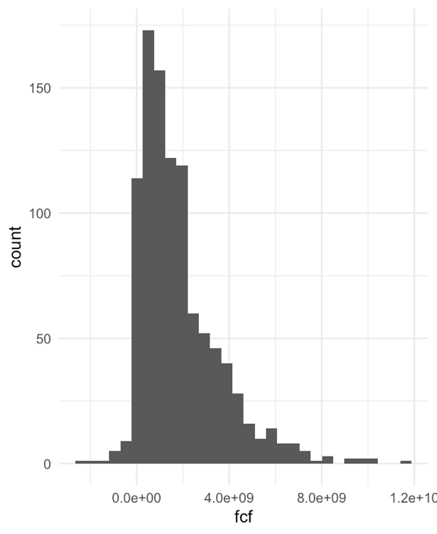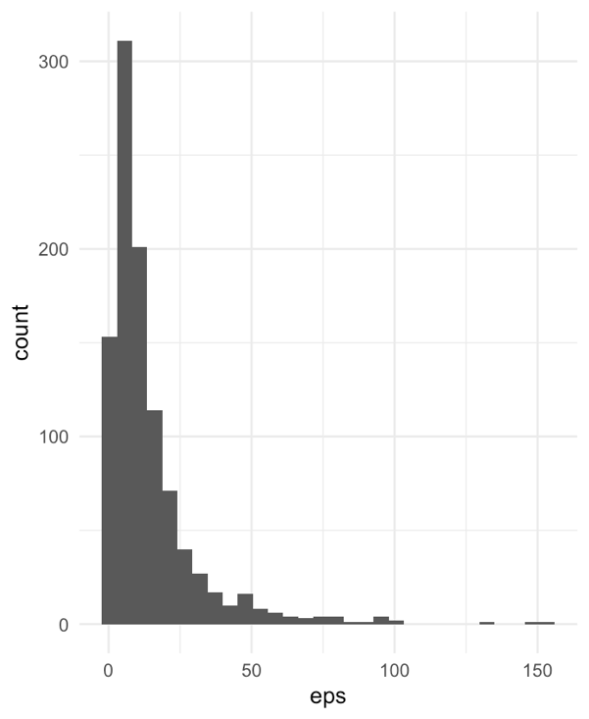
4.3 Time-Based Analysis (R)
Boxplots of revenue growth and net margin across years indicate that firm performance is relatively stable over time, with moderate fluctuations. While some variation is observed, particularly in the 2020-2021 period, there are no significant structural shifts across the dataset.
Figures 7 and 8: Boxplots of Revenue Growth and Net Margins
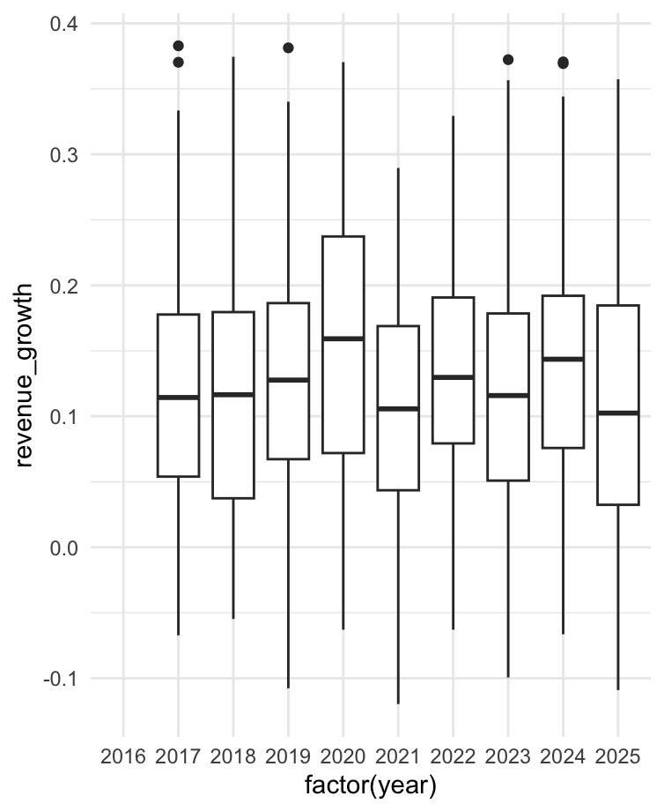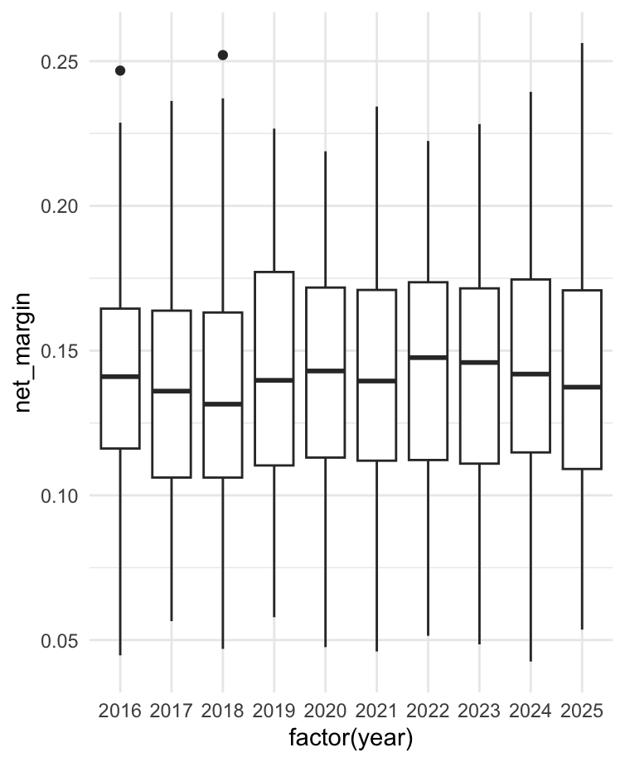
4.4 Relationship Analysis (R)
Scatter plots were used to examine relationships between key variables:
Debt ratio vs net margin (Figure 9) illustrated a weak relationship. There was no clear trend indicating that higher leverage consistently impacts profitability.
Figure 9: Debt Ratio vs Net Margin
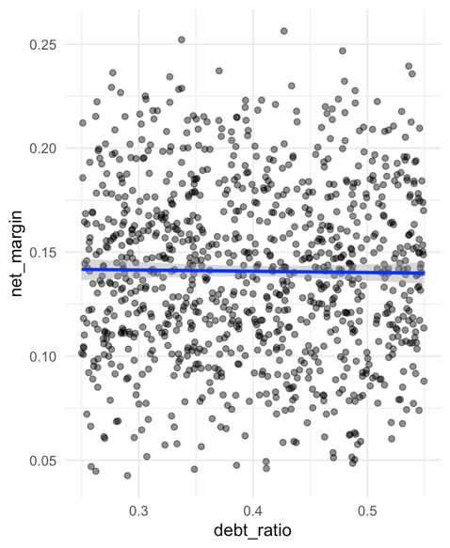
Asset turnover vs revenue per employee (Figure 10) similarly had no statistically meaningful linear relationship observed. This suggests that efficiency does not strongly translate into increased revenue productivity.
Figure 10: Assets turnover vs Revenue per employee
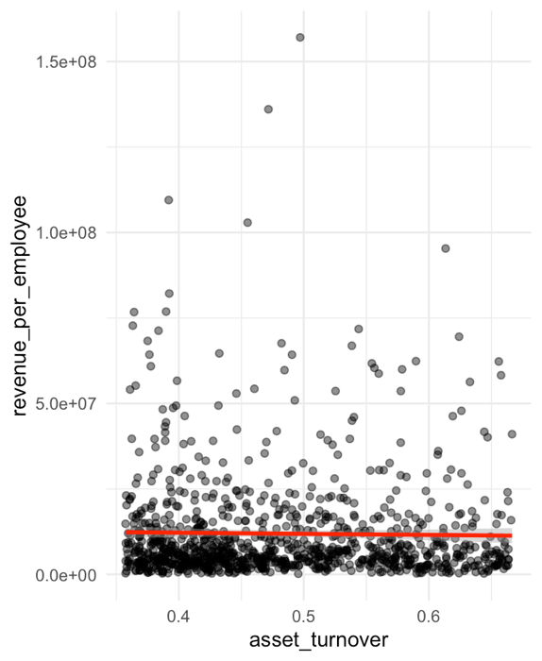
These findings challenge the assumption that leverage and efficiency are strong standalone drivers of financial performance. This suggests that these commonly cited drivers may operate indirectly or in combination with other factors, rather than exerting a linear influence on performance.
The weaker linear relationships observed suggest that a multivariate or regression-based approach better capture the underlying drivers of performance
4.5 Correlation Analysis (R)
A correlation heatmap (Figure 11) was used to evaluate linear relationships between key variables.
Strong correlations were observed between profitability measures (e.g., net margin and EBIT margin). However, weak correlations were found between: debt_ratio and net margin along with asset_turnover and revenue_growth.
This reinforces the conclusion that financial performance is not driven by a single factor, but rather a combination of multiple factors.

Figure 11: Correlation Heatmaps for Key Ratios and Metrics
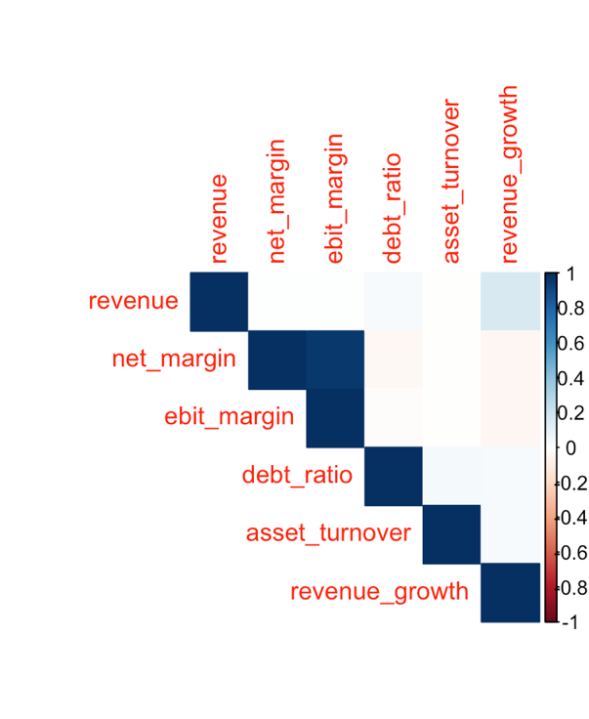
  - Composition Analysis
The domestic versus export split (Figure 12) varies enormously across companies. Companies 2 and 3 dominate in absolute size with Company 3 having a massive domestic sales (~350 B). The export-heavy companies suggest international revenue dependence, which carries some geopolitical risk. Most companies are domestic-dominant, which is consistent with the descriptive statistics.
Figure 12: Stacked bar chart: Composition of domestic vs. export sales by company (Tableau);
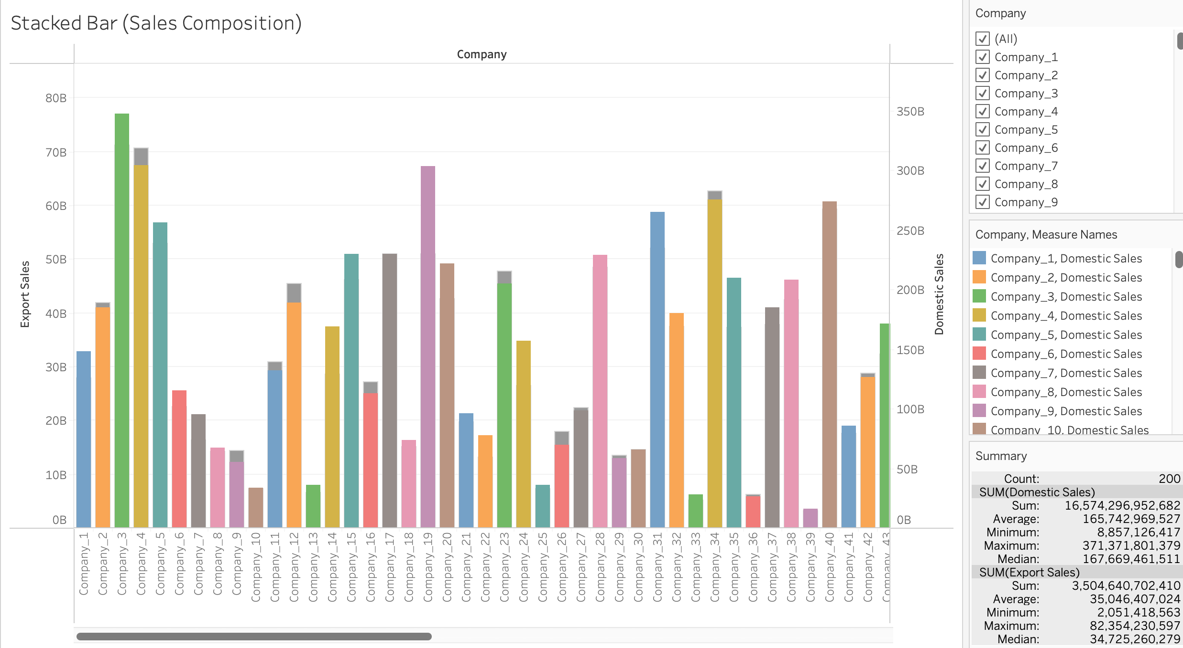
The wide disparity between companies reinforces the right-skewed revenue distribution.
  - Revenue Momentum Review
The heatmap (Figure 13) revealed 2019-2020 is noticeably muted/orange for several companies, consistent with the COVID disruption leading to negative-growth. 2022-2023 shows the deepest blues for many companies some of the strongest momentum.

Figure 13: Heatmap: Year-over-year revenue momentum across companies (Tableau)
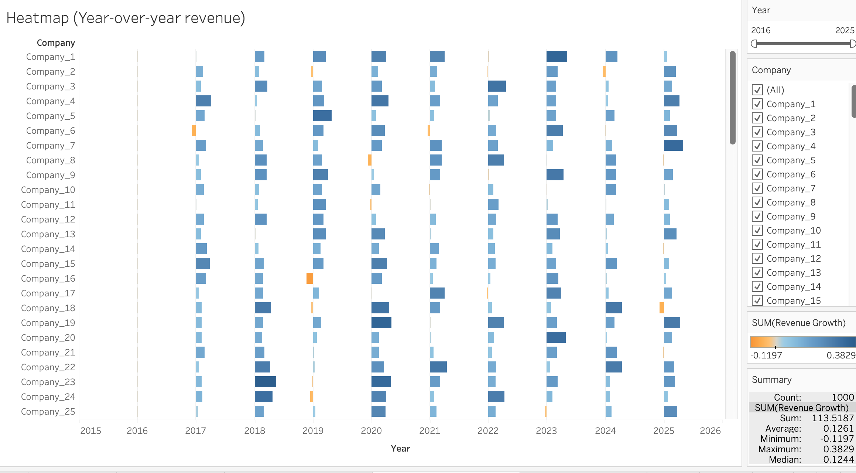
The overall picture demonstrates the consistent average growth, median, with negative growth being rare (minimum -11.97%).
  - Ranking Companies

Company 70 is the largest by average revenue (~$44.6B based on the tool),followed closely by Companies 94, 45, 83, 3, and 69.The size gradient confirms the skewed distribution = the top ~10 companies are substantially larger than the rest.

Figure 14: Treemap: Companies ranked by revenue (Tableau)
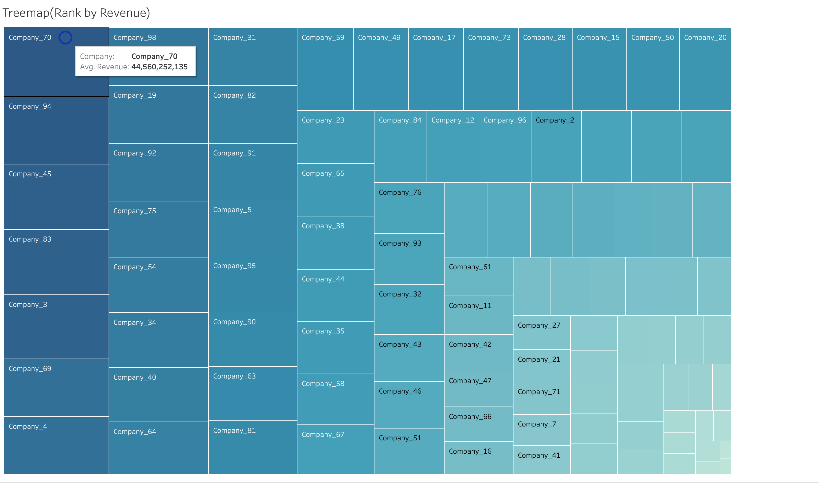
The fact that so many companies occupy small ties in the bottom-right illustrates the skewness further.
Key Visual insights
Profitability
The profitability of the firms are stable and structurally healthy. The margin stack holds firm at ~43% gross, ~19% EBIT, and ~14% net for the entire 2016-2025 period, across all 100 companies.

Figure 15: Top 20 Companies by Net, Gross, and EBIT Margin

This strongly suggests structurally disciplined cost management across the sample.

Figure 16: Average Annual Revenue of the Top 5 Companies (2016 - 2025)

Year-over- year the average annual revenue of the top 5 companies (Figure 15) shows a steady increase.
Figure 17: Average Net Margin of the Top 5 Companies by Annual Revenue (2016 - 2025)

These same top 5 companies also demonstrate net margins (Figure 16) year-over-year that range from ~6% to 23%.
Efficiency
Asset turnover trends gently upward from ~0.44 to ~0.50 over the decade, suggesting the sample as a whole is getting slightly more productive with its asset base. The graphical stacked bar (Figure 12) showed that domestic sales dominate (~80%+ for most companies), which means this efficiency gain is largely domestically driven. The treemap (Figure 14) confirmed a wide size dispersion, the largest companies (Company 70 and Company 94) are also among the more asset-efficiency, consistent with scale effects.
Leverage
The average debt ratio sits at 0.40 throughout, with the equity ratio as its mirror at 0.60. The near-zero skewness on both metrics confirms no systemic drift toward over- or under-leverage. However, the descriptive statistics showed a standard deviation of ~0.087 meaning some companies sit at 0.25 (conservatively financed) and other near 0.55 (meaningfully leveraged). The heatmap (Figure 13) showed Company 6 and Company 16 as persistent underperformers, and their debt ratios in the CSV are on the higher side, suggesting leverage is one contributor to their weaker growth momentum.
Growth
Revenue growth averages ~12.6% across the sample, but the heatmap made the time dimension visible: 2019-2020 were the only broadly negative years, 2022-2023 showed the deepest blue (strongest growth, and 2025 shows some cooling. The high coefficient of variation (~88%) on revenue growth means the average hides substantial company-level divergence. The treemap (Figure 14) and stacked bar (Figure 12) together illustrate that growth leaders are also the revenue giants, reinforcing a pattern where scale and growth compound each other.
Overall, this is a high-quality, mature, domestically oriented sample that is profitable, modestly leveraged, and increasingly efficient.
Tableau Dashboards
Two dashboards (Figure 18 and 19) were developed to provide interactive summaries of the data.
Dashboard 1 – Financial 1 Financial Performance Overview, displays revenue trends, profitability metrics, and key performance indicators. It allows for comparison across firms and time.
The average revenue line chart confirms the compounding growth story clearly from ~$11B in 2016 to ~$33B by 2025, roughly tripling over the decade with acceleration particularly visible after 2021.
The net margin chart appears aggregated rather than expressed as percentages, which explains the observed scale. This aligns with the earlier finding that net margins cluster tightly at 12-18% at the individual company level.

Figure 18: Dashboard 1 - Financial Performance Overview
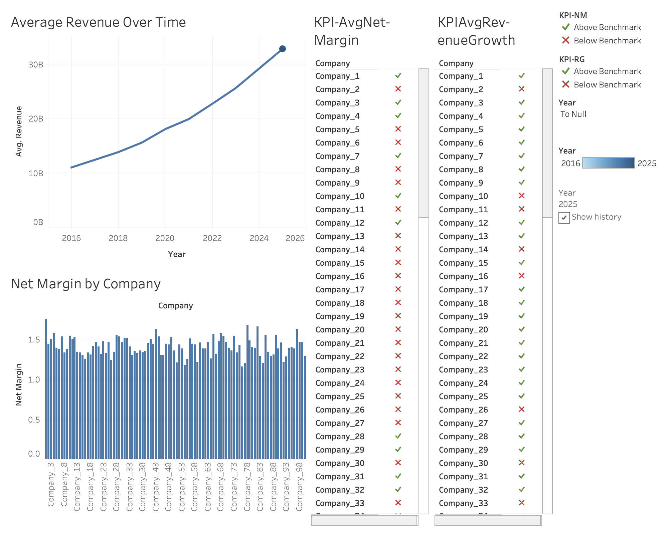
The KPI scorecards break companies into “above” vs “below” benchmark on both the net margin and revenue growth revealing clear segmentation.
Dashboard 2 – Leverage & Liquidity, visualizes debt ratio, cash ratio, and working capital. It provides insight into firm financial structure and stability.
The cash ratio histogram illustrates right-skewed with a peak around 0.08-0.12, meaning most companies hold relatively lean cash positions relative current liabilities. The long tail stretching to 0.30+ represents a small group of companies with unusually strong liquidity buffers – consistently with the earlier descriptive statistics showing cash ratio mean (~0.14) well above the median, increased by those outliers.
The debt ratio treemap confirms what the descriptive stats showed: the range is narrow (0.35-0.48 across the color scale), meaning even the most leveraged companies in this sample aren’t dangerously indebted. There’s no clustering of extreme values – the color gradient is gradual.

Figure 19: Dashboard 2 - Leverage & Liquidity
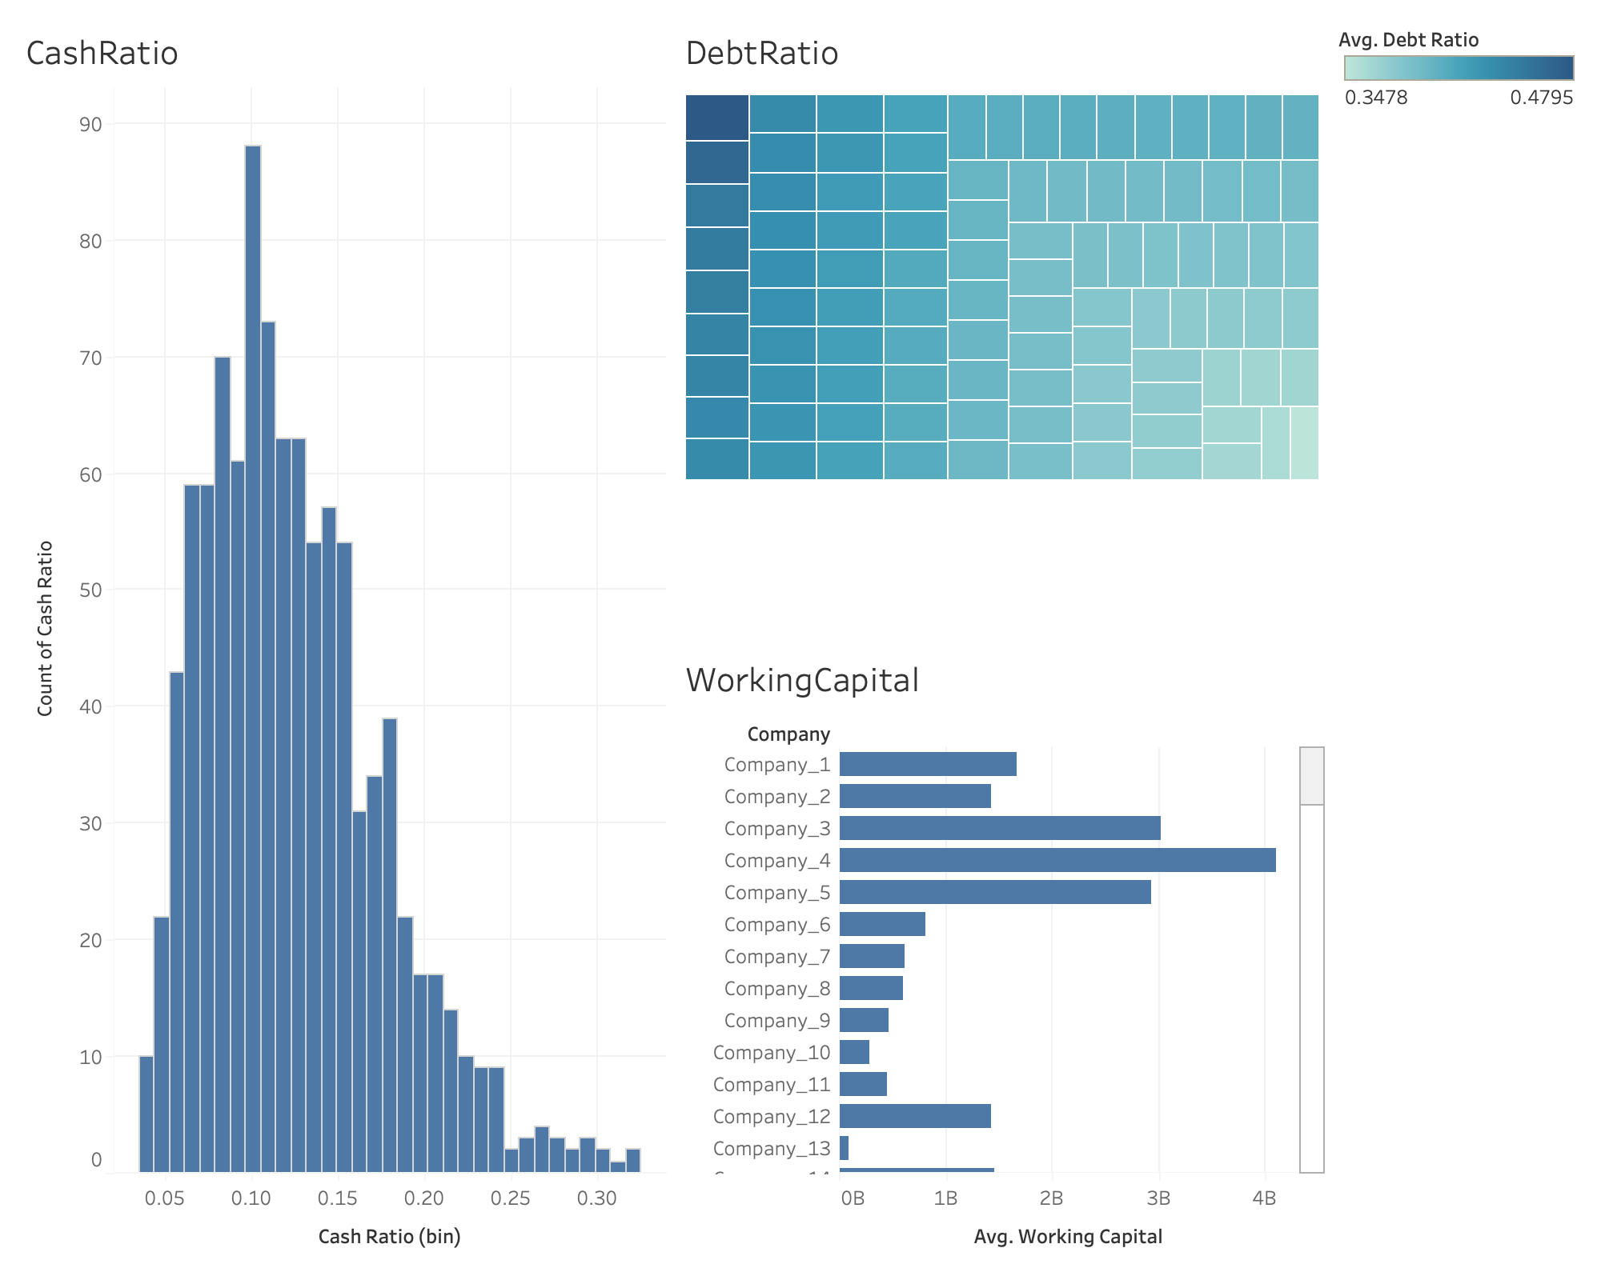
The working capital bar chart illustrates varying levels across organizations. Company 4 with dramatically the highest in this snapshot (~$4B). Company 13 sits near zero, suggesting very tight liquidity management or business model with minimal working capital needs.
These dashboards complement the statistical analysis by offering a high-level, interactive view of firm performance.
Conclusion
Overall, the findings highlight that firm performance is not driven by isolated financial ratios, but rather emerges from the interaction of scale, growth dynamics, and operation discipline.
The exploratory analysis revealed financially healthy and structurally stable sample. Profitability margins remained remarkably consistent throughout decade, with net margin holding at ~14%, EBIT margin at ~19%, and gross margin at ~43% on average across all firms and years. This stability, combined with narrow coefficient of variation on margins (~18-30%), suggests disciplined cost management rather than transient favorable conditions. Revenue, on the other hand, told a different story: highly skewed with a coefficient of variation of ~70%, and driven disproportionately by a small cluster of revenue giants, a pattern consistently reinforced across the descriptive statistics, treemap, and stacked bar visualizations.
Regarding the central question of the analysis, the findings challenge the assumption that leverage and efficiency are strong standalone drivers of performance. The scatter plots and correlation heatmap both revealed weak relationships between the debt ratio and net margin, and between asset turnover and revenue growth. This suggests that within this sample, moderate leverage and improving asset efficiency are present but not the primary explanatory factors behind profitability differences across firms. Instead, performance variation appears to be more closely tied to firm scale and the compounding effect of sustained revenue growth, as evidenced by the KPI scorecards and revenue momentum heatmap.
Leverage across the sample is moderate and stable, averaging0.40 with no systemic drift in either direction. While a few firms, notably Company 6 and 16, show higher debt ratios alongside weaker growth momentum, this remains an observation rather than a confirmed causal relationship given the weak overall correlation. Liquidity, as shown in the cash ratio histogram and working capital bar chart, is generally adequate, though with meaningful variation: most firms maintain lean cash positions, while a small tail holds considerably stronger liquidity buffers.
Growth is the most variable dimension of performance, with a coefficient with of ~88%, and the heatmap clearly captured the observable macro shock, the 2019-2020 period of muted or negative growth, followed by a strong 2022-2023 rebound. The acceleration in average return from ~$11B in 2016 to ~$33B by 2025 underscores that this is not a stagnant sample, but one experiencing meaningful compounding growth, concentrated particularly among the largest firms.
In summary, this analysis finds that financial performance in this sample is broad-based and structurally sound, but less driven by leverage and efficiency in isolation, and more by the interaction of firm scale, revenue momentum, and consistent cost discipline. Future analysis could extend these findings through regression modeling to formerly quantify the relative contribution of each driver, or through segmentation analysis to distinguish whether the dual outperformers identified in the KPI scorecards share common structural characteristics that explain their sustained advantage.

Appendix
R Code
Appendix A: R Code for Correlation Heatmap
library(tidyverse)
library(corrplot)

data <- read.csv("financial_200_features_dataset.csv")

selected <- data %>%
select(revenue, net_margin, ebit_margin, debt_ratio, asset_turnover, revenue_growth)

cor_matrix <- cor(selected, use="complete.obs")

corrplot(cor_matrix, method="color", type="upper")

Appendix B: R Code for Scatter Plots
library(tidyverse)
data <- read.csv("financial_200_features_dataset.csv")

selected <- data %>%
select(revenue, net_margin, ebit_margin, debt_ratio, asset_turnover, revenue_growth)

ggplot(data, aes(x = debt_ratio, y = net_margin)) +
geom_point(alpha=0.5) +
geom_smooth(method="lm", color="blue") +
theme_minimal()
ggplot(data, aes(x = asset_turnover, y = revenue_per_employee)) +
geom_point(alpha=0.5) +
geom_smooth(method="lm", color="red") +
theme_minimal()
Appendix C: R Code for Boxplots (Distribution Over Time)
library(tidyverse)

data <- read.csv("financial_200_features_dataset.csv")

selected <- data %>%
select(revenue, net_margin, ebit_margin, debt_ratio, asset_turnover, revenue_growth)
ggplot(data, aes(x = factor(year), y = net_margin)) +
geom_boxplot() +
theme_minimal()
ggplot(data, aes(x = factor(year), y = revenue_growth)) +
geom_boxplot() +
theme_minimal()
Appendix D: R Code for Histogram (EPS+FCF)
library(tidyverse)

data <- read.csv("financial_200_features_dataset.csv")

selected <- data %>%
select(eps, fcf, revenue, net_margin, ebit_margin, debt_ratio, asset_turnover, revenue_growth)
ggplot(data, aes(x = eps)) +
geom_histogram(bins=30) +
theme_minimal()
ggplot(data, aes(x = fcf)) +
geom_histogram(bins=30) +
theme_minimal()

